Experiment 1: Vector and Matrix Operations for Deep Learning

1. Aim
To perform vector and matrix operations used in a neural network dense layer and recommendation system, calculate customer–book scores, identify similar customers using cosine similarity, and visualize the resulting score matrix using NumPy and Matplotlib.

2. Formula(s)
Dot product: a·b = Σ(aᵢbᵢ)
Matrix multiplication: C = AB
Dense layer: y = Wx + b
Cosine similarity: cos(θ) = (a·b)/(‖a‖‖b‖)
Matrix inverse: A⁻¹A = I (only for invertible square A).

3. Overall Flow Diagram
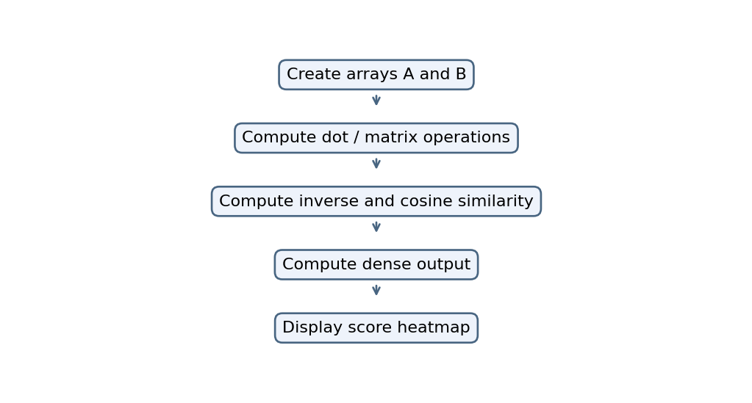

4. Code :

import numpy as np

import matplotlib.pyplot as plt

customer_genre = np.array([

[5, 4, 1, 0, 2],

[4, 5, 1, 0, 1],

[1, 0, 5, 4, 3],

[0, 1, 4, 5, 4],

[3, 2, 2, 1, 5],

[2, 1, 3, 2, 5]

], dtype=float)

genre_book = np.array([

[0.9, 0.2, 0.1, 0.0],

[0.8, 0.3, 0.0, 0.1],

[0.1, 0.9, 0.2, 0.3],

[0.0, 0.7, 0.8, 0.2],

[0.2, 0.1, 0.4, 0.9]

], dtype=float)

print("Dot Product:",

np.dot(customer_genre[0], customer_genre[1]))

score_matrix = customer_genre @ genre_book

print("Customer-Book Score Matrix:\n",

np.round(score_matrix, 2))

print("Transpose:\n", customer_genre.T)

print("Element-wise Multiplication:\n",

customer_genre * customer_genre)

C = np.array([[1.0, 2.0],

[3.0, 4.0]])

print("Inverse:\n", np.linalg.inv(C))

norms = np.linalg.norm(customer_genre, axis=1)

similarity = (

customer_genre @ customer_genre.T

) / np.outer(norms, norms)

np.fill_diagonal(similarity, -1)

print("Cosine Similarity Matrix:\n",

np.round(similarity, 3))

i, j = np.unravel_index(

np.argmax(similarity), similarity.shape

)

print("Most Similar Customers:",

i + 1, "and", j + 1)

print("Cosine Similarity:",

round(similarity[i, j], 4))

W = genre_book.T

x = customer_genre[0]

b = np.array([0.1, 0.1, 0.1, 0.1])

y = W @ x + b

print("Dense Layer Output:", np.round(y, 2))

plt.figure(figsize=(7, 5))

plt.imshow(score_matrix, cmap="Blues", aspect="auto")

plt.colorbar(label="Recommendation Score")

plt.xticks(range(4),

["Book 1", "Book 2", "Book 3", "Book 4"])

plt.yticks(range(6),

["Customer 1", "Customer 2", "Customer 3",

"Customer 4", "Customer 5", "Customer 6"])

plt.xlabel("Books")

plt.ylabel("Customers")

plt.title("Customer-Book Score Heatmap")

for row in range(score_matrix.shape[0]):

for col in range(score_matrix.shape[1]):

plt.text(

col, row,

f"{score_matrix[row, col]:.2f}",

ha="center", va="center"

)

plt.tight_layout()

plt.show()

5. Output
Dot Product: 32.0
Customer–Book Score Matrix:
[[8.2 3.3 1.5 2.5]
[7.9 3.3 1. 1.7]
[2. 7.8 5.5 5. ]
[2. 7.8 6.4 5.9]
[5.5 4.2 3.5 5.5]
[3.9 5.3 4.4 5.9]]
Transpose of Customer–Genre Matrix:
[[5. 4. 1. 0. 3. 2.]
[4. 5. 0. 1. 2. 1.]
[1. 1. 5. 4. 2. 3.]
[0. 0. 4. 5. 1. 2.]
[2. 1. 3. 4. 5. 5.]]
Element-wise Multiplication:
[[25. 16. 1. 0. 4.]
[16. 25. 1. 0. 1.]
[ 1. 0. 25. 16. 9.]
[ 0. 1. 16. 25. 16.]
[ 9. 4. 4. 1. 25.]
[ 4. 1. 9. 4. 25.]]
Inverse of Matrix C:
[[-2. 1. ]
[ 1.5 -0.5]]
Most Similar Customers:
Customer 1 and Customer 2
Cosine Similarity: 0.9668
Dense Layer Output for Customer 1:
[8.3 3.4 1.6 2.6]

Graph
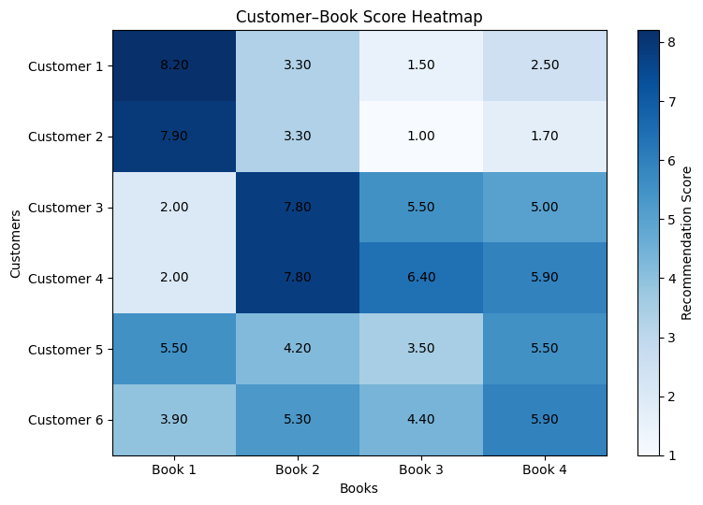

6. Result
Vector and matrix operations were performed successfully using NumPy. Cosine similarity identified the most similar customers, the dense layer output was calculated, and the customer–book score matrix was visualized using a heatmap.

